Deep Cosmos Navigation System

# Sample Code and Screenshot

## Screenshot

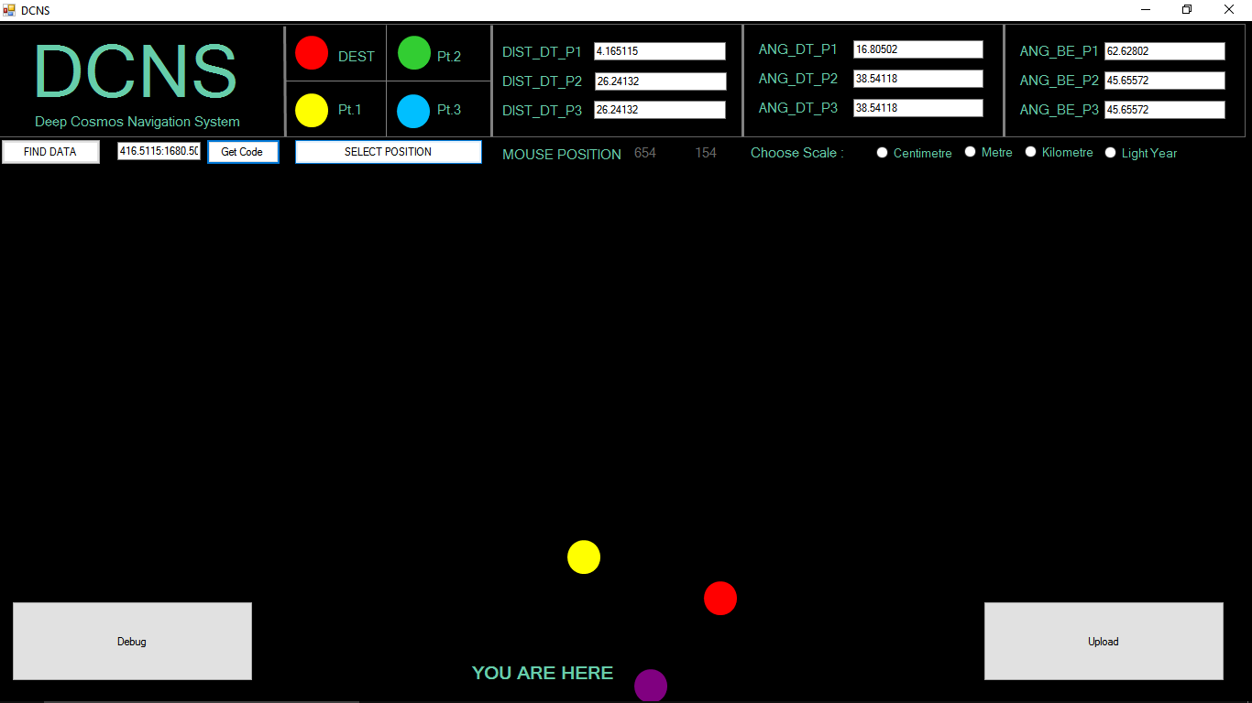

## sample code

416.5115:1680.502:6262.802:200:3165.127:256.896:203.376:1:2